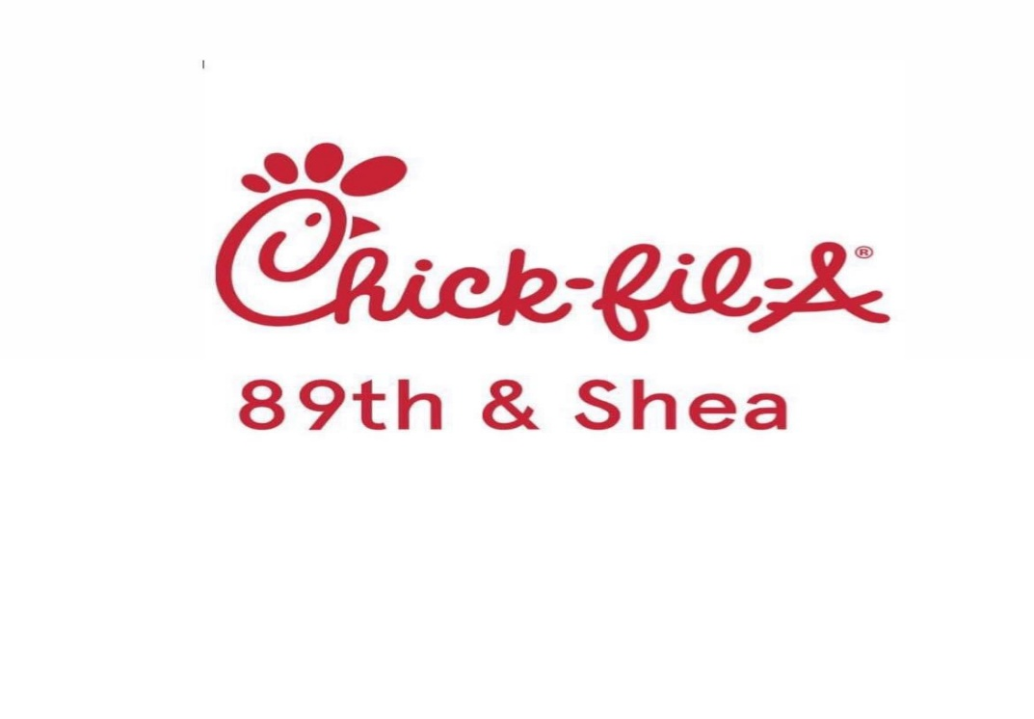

COME JOIN THE DESERT MOUNTAIN HIGH SCHOOL GIRLS FLAG FOOTBALL TEAM FOR SPIRIT NIGHT AT **CHIX-FIL-A, 89th AND SHEA**

Monday November 3rd from 4-7 PM

20% of sales go back to the DMHS Girls Flag Football Boosters

**IMPORTANT!!!!!!!**

Here’s how it works:

1. Place a Chick-fil-A **mobile order** (at their table or in the Drive-Thru) **through the Chick-fil-A app**.

2. At Checkout, they simply toggle the **“Support Community Care Event”** button